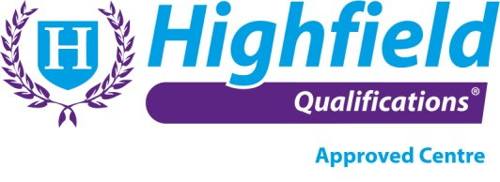 | Legionella Awareness Training: Booking Form
Contact Name:

Company Name & Address:

Postcode:
Telephone:
Email:
Course Required: | Highfield Level 3: Legionella Awareness  – Responsible Persons
Date of Course: | Tuesday 7th October 2025
Course Location: | Central London

Delegate Information: (maximum of 15 delegates)

Delegate Full Name | Delegate D.O.B | Delegate Gender | Any reasonable adjustments / special considerations / dietary requirements  (further information may be required)

